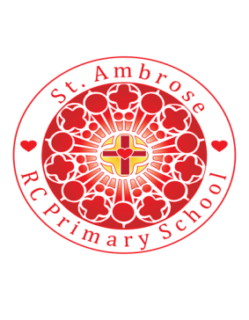
St Ambrose R.C. Primary School
Loving minds
hearts
hands.

Princess Road
Chorlton-cum-Hardy
Manchester M21 7QA
Tel: (0161) 445 3299

Head teacher: Mrs R Vayro
Email: head@st-ambrose.manchester.sch.uk
Website: www.st-ambrose.manchester.sch.uk

This term we will be learning lots of new and exciting things!
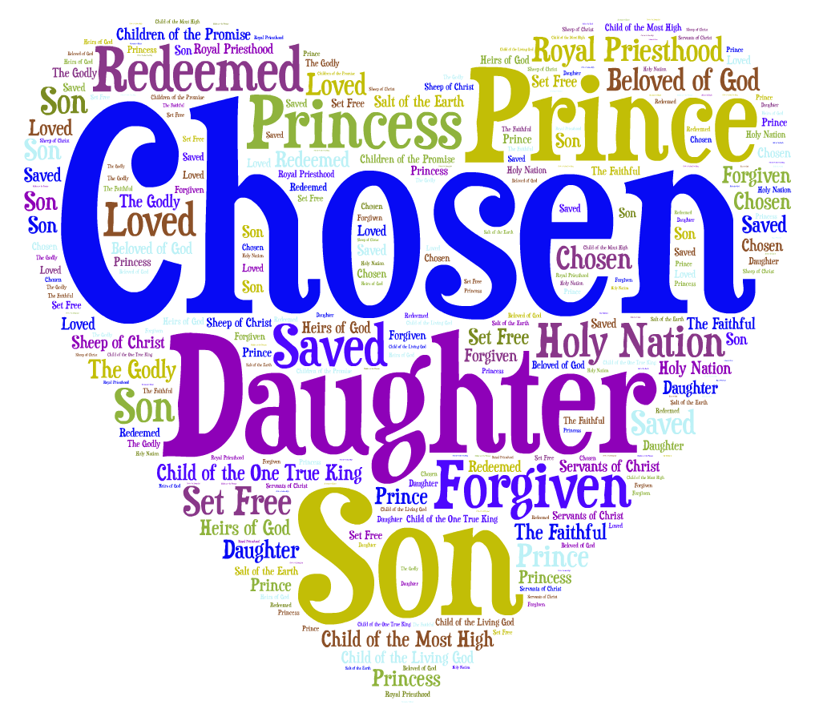
RE
To start off the year, we will be focussing on our names. We will be talking about our names and why they are different. We will be asking you why you chose your child’s name and the meaning of it. This will fit nicely with our writing focus for the start of the year, which will ensure all the children can write their name confidently and independently. We will then start to introduce the idea of our second name and how this is our family name.

We hope you will be able to join us for our Para-Liturgy on Friday 4th October at 9am to celebrate the learning we do in the topic. Put the date in your diary now!
Literacy

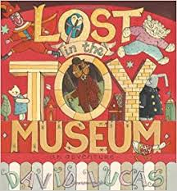
In Reception, the children continue to gain valuable learning experiences through quality texts. This half term our theme is ‘toys’. We will be reading ‘Lost in the Toy Museum’ by David Lucas and ‘Kipper’s Toy Box’ by Mick Inkpen. Both these texts are engaging and full of adventure for the children to delve into. Lost in the Toy Museum will give the children opportunities to explore different story themes and start to describe and talk about different characters in books. They will also have lots of writing opportunities with creating their own toy characters. We have a toy shop in the Reception classroom to bring the stories to life! Please have a look on our class webpage for the children’s learning and YouTube links on the books we are reading.

RWI

The children have started Read Write Inc from the first day after being put into groups at the end of Nursery. Read Write Inc. is an essential part of the Reception curriculum at St. Ambrose as it gives the children the skills to read and write. The children are grouped according to how many sounds they know and assessments are completed half termly so the children are always in the correct group.

The children need to know all single letter sounds and should be starting to blend them together orally e.g. s-a-d, sad. They should also be forming letters correctly and over learning at home will be hugely beneficial to the children.
Reading at home
To help your child learn to blend and read words, before we send home a reading book with the reading record we have found it hugely beneficial to send home simple words that the children should be able to blend e.g. m-a-t, mat. Your child should practise the words at home and someone at home should sign the reading record. We will then practice them in school everyday. When your child knows the words in their envelope they will be given more to practice.

Included in the envelope are also some words that every reception child needs to learn. Phonics cannot be used to decode these words and they must be learnt from sight. Learning these words will help your child to access reading books sooner.

Maths
This half term, we will be focussing on recognising numbers to 5. We will concentrate on counting a group of objects and matching the correct number. We will also practise counting an irregular group of objects.

We will then move onto Shape, space and measure and we will revisit and revise our knowledge of 2D shapes and begin to describe them.
P.E.
This year the children will start P.E. lessons with Mr Warburton on a Friday morning. The children will need a full P.E. kit which consists of a white polo shirt, black shorts or jogging bottoms and black pumps. This must be kept in a drawstring back on their peg and should be kept in school for the half term. The children will do sessions in the hall as well as outside so it is vital the children have a pair of pumps/trainers to access the full curriculum.

It is also vital that your child can attempt to dress and undress themselves so the children get the most out of the P.E. session.

Please check our website regularly, where current learning is displayed as well as lots of informative advice. If there is anything else you would find helpful please ask!
http://www.st-ambrose.manchester.sch.uk/parent-information/classes/reception

