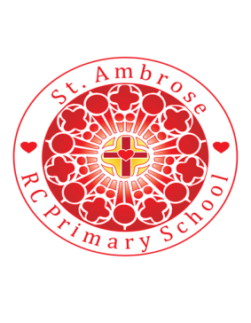
St Ambrose R.C. Primary School
Loving minds
hearts
hands.

Princess Road
Chorlton-cum-Hardy
Manchester M21 7QA
Tel: (0161) 445 3299

Head teacher: Mrs R Vayro
Email: head@st-ambrose.manchester.sch.uk
Website: www.st-ambrose.manchester.sch.uk

Year 5 Autumn Term 1 - Share in Our Learning
This term we will be learning lots of new and exciting things!
Home learning and Reading
Children need to read regularly at home (every night where possible) and this needs to be recorded in their reading diaries and returned each day. Every week children are given a set of spellings to learn for a weekly test on a Friday.
Maths Question books and English comprehension books or Literacy and Language Homework books will be given to the children each Thursday and the children are expected to complete a page and return this on the following Tuesday.
Home learning in Science, Religion, History or Geography may also be set where appropriate. Any research done at home will help with their learning. Please could you encourage your child to not copy from books or the internet but to adapt and write in their own words. Also they need to find or draw pictures and diagrams to support their writing.
My Book Club – children now all have their own log in where they can read online books and answer questions to gain credits.
RE
The school uses as a basis a scheme called Come and See. In this half term’s topic, the children will learn that
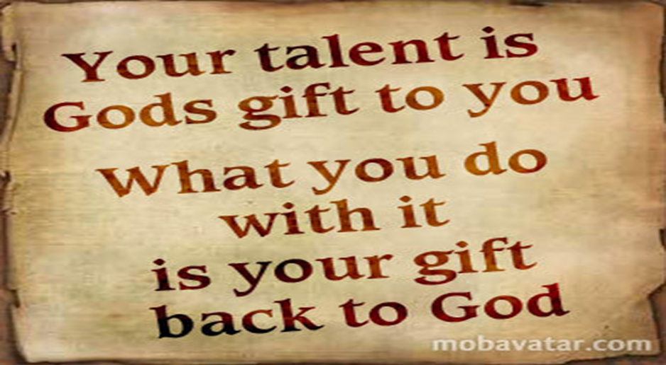
“Each person is made in the image and likeness of God. To know ourselves and to appreciate that our value and uniqueness is central to our wellbeing.” Later on in the half term the children will understand more about Baptism and how we are called to a life of holiness and to the mission of spreading the Good News. That life may be lived out in different ways and for some that may be marriage. We will help plan a marriage ceremony.

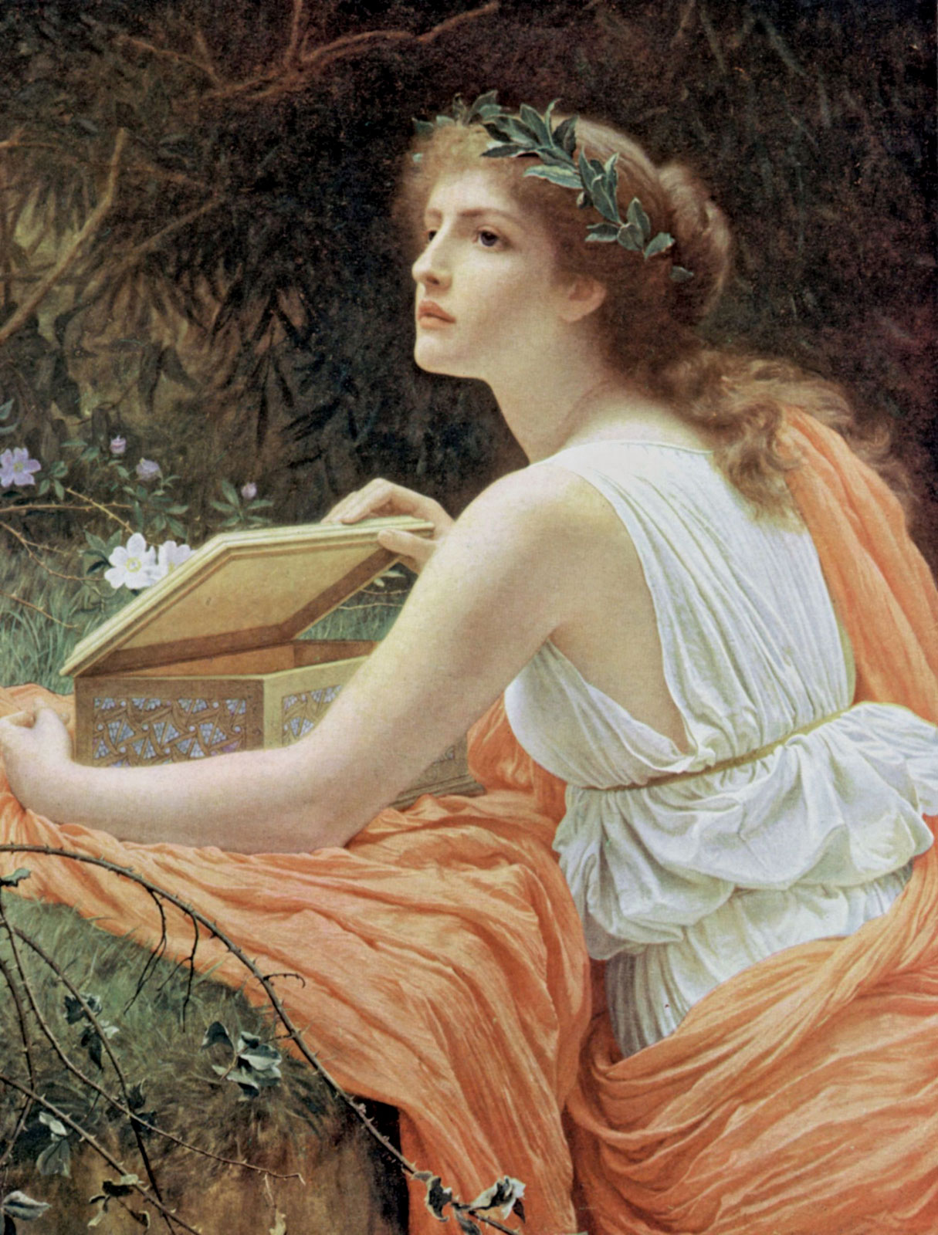
English
We follow a scheme called Literacy and Language. In the Fiction section the children will study the story of Prometheus and Pandora. It has been chosen for its strong mythological themes and characteristics. Children will analyse the importance of different characters to the development of the story and the role of the narrator as storyteller. The Non-fiction section of this half term will develop the children’s understanding of the features of instructional writing. They will analyse, evaluate and write instructions.

Maths
The children will be improving the speed of mental recall for multiplication facts (up to 12 x12) and related division facts. We will be improving our basic maths skills. Children need to be competent with numbers at least up to one million. Efficient written methods will be learnt for addition, subtraction. Once the children have shown fluency in the learning the children will be reasoning with numbers and solving problems to deepen their understanding.
The children will also cover some of the geometry unit missed in Year 4 due to Covid 19.
Science: Properties and Changes of Materials
The children will compare and group together everyday materials on the basis of their properties, including their hardness, solubility, transparency, conductivity (electrical and thermal), and response to magnets. They will know that some materials will dissolve in liquid to form a solution, and describe how to recover a substance from a solution
The children will also get a chance to learn about “Sound”, one of the Year 4 topics missed due to Covid 19.
History: Anglo-Saxons
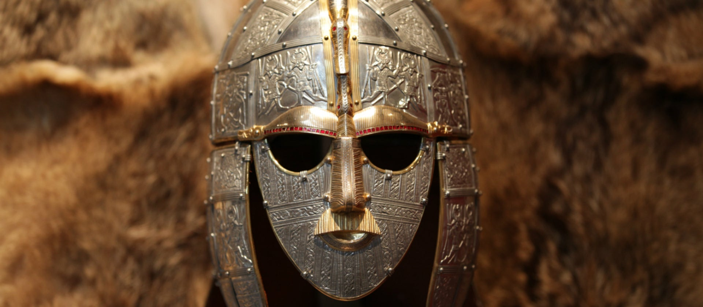
Learning will include
- Timeline: where Anglo-Saxons fit in with the main eras and what is their legacy e.g. place names.
- Mapwork: settlements and where did the Angles and the Saxons come from.
- What evidence is there of Anglo-Saxons in Greater Manchester e.g. place names, coins, Manchester Cathedral. Daily life of the Anglo-Saxons: children, homes, clothes, religion, food, jobs
- The story of Sutton Hoo
- Runic writing. Where did the runes come from? Legacy. Illuminated letters art work.
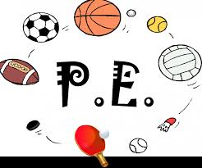
P.E.:
Children will have “Games” on a Wednesday afternoon and “Gymnastics” on a Thursday afternoon with Mr Warburton. The children need to keep their PE kit in school and take it home at the end of each half term to be washed.
Computing: Online Safety and Spreadsheets.
Music: The children will be producing their own compositions using a wide range of musical instruments. A specialist teacher will be teaching the children.
French: The theme will be “Journey to School”
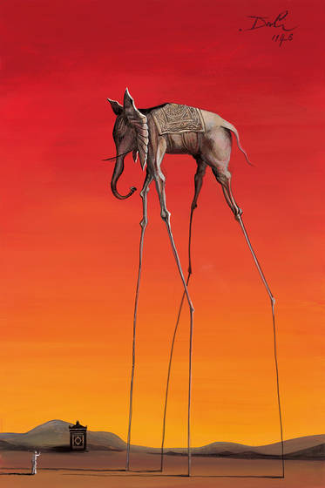
Art:
The children will be using the painting “Elephants” by Salvador Dali to explore colour blending and complimentary colours as well as looking into the world of surrealism.

Activities to enjoy at home: Any research done at home will help with their topic. Please could you encourage your child to not copy from books or the internet but to adapt and write in their own words. Also they need to find or draw pictures and diagrams to support their writing.
READ! READ! READ! Newspapers, magazines, football programmes, story books – anything and everything!!!
Useful websites.
KS2 bitesize My book blog
CBBC Newsround Purple Mash and TT rockstars

