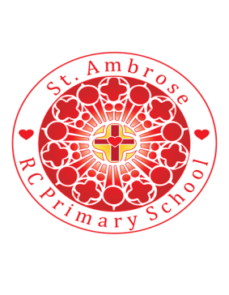
St Ambrose R.C. Primary School
Loving minds
hearts
hands.

Princess Road
Chorlton-cum-Hardy
Manchester M21 7QA
Tel: (0161) 445 3299

Head teacher: Mrs R Vayro
Email: head@st-ambrose.manchester.sch.uk
Website: www.st-ambrose.manchester.sch.uk

Autumn 1 Year 4 Share in Our Learning Letter
This term we will be learning lots of new and exciting things!
Home learning and Reading
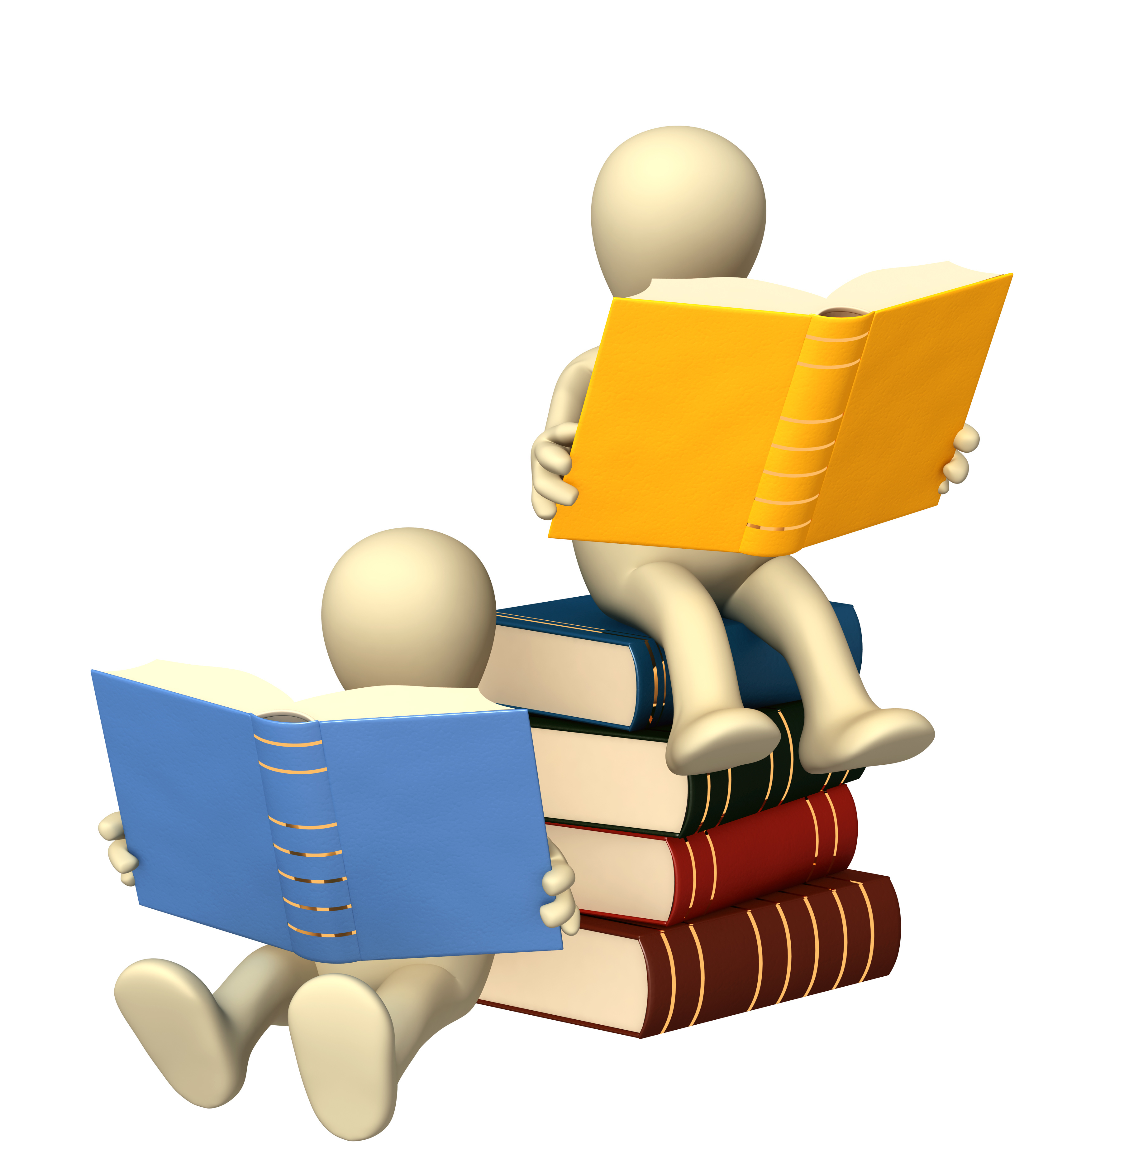
Daily reading is extremely important. We are listening to your child read every day in school and we expect you to listen to your child read every day for 5-10 minutes at home. Please sign their reading record every time you read with them. My Book Blog is being used and children are encouraged to use the resources. Home-learning will be a combination of maths, literacy and curriculum learning. This will be sent home on Thursday and one page of maths and literacy should be completed and returned to school by Tuesday morning. Spellings will be sent home every Friday to practise for a spelling test on the following Friday. Please practise daily with your child. There is a curriculum expectation that all children should know all times tables to 12x12 by the end of Year 4. In June, children in Year 4 are expected by the government to take a times tables test. Your child is expected to do regular practice on Times Tables Rock Stars and this will be monitored and assessed.
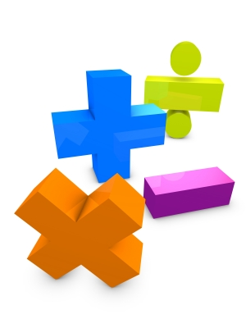
Maths: Place Value, Addition and Subtraction
The children will count in multiples of 6, 7, 9. 25 and 1000. They will find 1000 more or less than a given number and count backwards through zero to include negative numbers. Your child will recognise the place value of each digit in a four digit number (thousands, hundreds, tens and ones) and order and compare numbers beyond 1000. The children will round any number to the nearest 10, 100 or 1000. They will solve number and practical problems that involve all of the above and with increasingly large positive numbers. The children will learn to read Roman numerals to 100 (I to C). They will add and subtract numbers with up to 4 digits using the formal written methods of columnar addition and subtraction where appropriate. The children will estimate and use inverse operations to check answers to a calculation. They will solve addition and subtraction two step problems in contexts, deciding which operations and methods to use and why.
RE: The Domestic Church
Through this unit the children will learn about the key concept of the Church being nothing but God’s family. The topic explores the truth that Jesus had a natural family with real people with names and history. The children will be exploring their own family trees and will need your help in this.
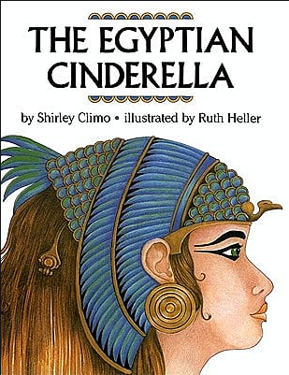
English: The Egyptian Cinderella
In this unit the children will use The Egyptian Cinderella to explore the features of fairy tales. The children will write their own tale set in Ancient Egypt. The children will focus on using direct speech which is punctuated correctly and organising their writing in paragraphs. They will explore the features of non-chronological reports and how these help the reader to find information easily.
Science: Who Am I? Human Impact
In this module children will further develop the understanding of keys they gained in the Year 3 rocks module, using them to identify animals from a range of habitats. They will also construct keys, learning to ask yes/no questions about characteristic differences between the animals. They will learn about pond and seashore animals and common land invertebrates through images and first-hand experience. In Human Impact the children will learn about some of the positive and negative ways that humans change the environment, locally and globally, with a particular focus on how this affects other living things. They will begin to understand that actions can have both positive and negative consequences, that situations are not black and white, and that decisions involve compromises. They will consider how industry, housing and thoughtless behaviour can damage local habitats and also how humans can increase biodiversity by developing environments such as country parks and nature reserves.
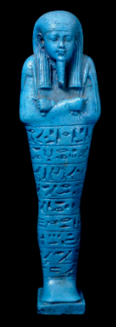
History: The Ancient Egyptians
The children will be using primary and secondary sources to learn about the beliefs of the Ancient Egyptians and exploring why we know so much about the ancient civilisation. They will learn about the importance of the Nile, mummification, the purpose of the tombs and Howard Carter. Our learning will be based around the shabti that we have in our entrance hall which is an Egyptian artefact we have on loan from Manchester Museum. There are so many exciting things we could do in this topic. If your child chooses to do any other activities or visits a museum with an Egyptian display we would love to hear about. If you or a member of your family have been to Egypt and have photos that they could share with us we would love to see them.
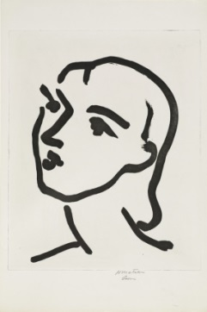
Art: Portraits and Henry Matisse
In art this half term, the children will focus on portraits and in particularly, in the style of artist – Henry Matisse. Children will experiment with different grades of pencil and other implements to draw different forms and shapes and also begin to show an awareness of objects having a third dimension.
Computing: Online Safety
This half term, the children will explore the key concepts relating to online safety and help others to understand the importance of staying safe online through the use of Purple Mash.
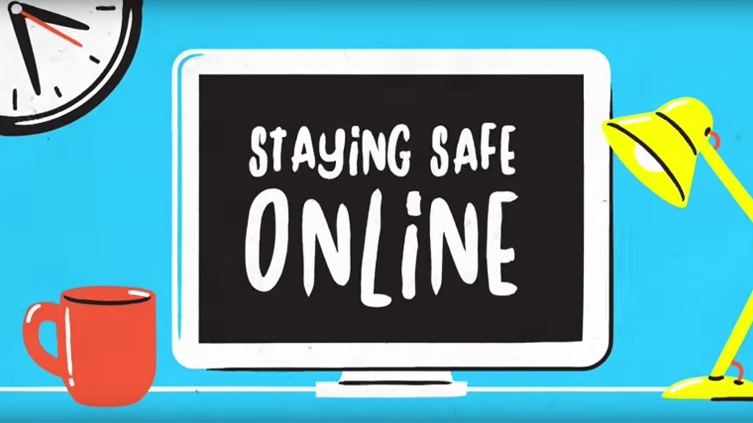
Children will learn to recognise the main component parts of hardware which allow computers to form a network.
Music: Jazz

The children will learn about the genre of Jazz music. They will focus on the composers and performers of accessible jazz such as Louis Armstrong, Dave Brubeck and Duke Ellington. It may be useful to listen to some of this genre together and think about what you like about it, what you don’t like about it and how the music makes you feel.
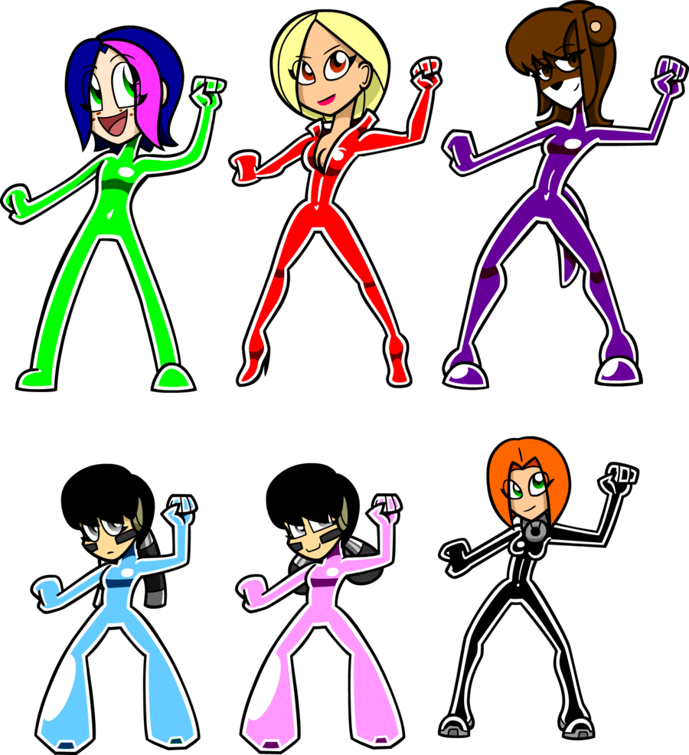
P.E.
The children will go swimming on a Wednesday morning and will have games on a Wednesday afternoon. Please ensure that they have the correct PE kit in school and that it stays in school for the half term: plain white T shirt, navy or black shorts and pumps or trainers. For swimming, all children need a towel; boys need trunks (not baggy) and girls need a one-piece swimsuit and hat.
French: People
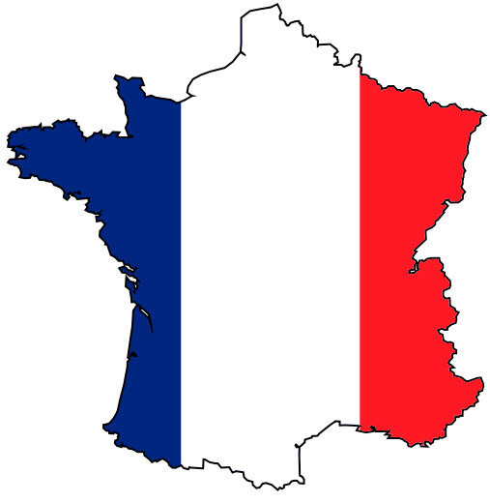
The children will be learning words and phrases about appearance and will give a simple description of a person.
Useful websites and further information:
www.st-ambrose.manchester.sch.uk https://classroom.thenational.academy/subjects-by-year/year-4
https://mybookblog.org/plogin/st-ambrose-rc-primar/ www.bbc.co.uk/bitesize/ks2 https://www.museum.manchester.ac.uk/collection/ancientegyptandsudan/
Please look at our class homepage on our school website. If there is anything you’d like to see on there, please let us know. The Meet the Teacher Powerpoint is also on the class web page with useful information.

