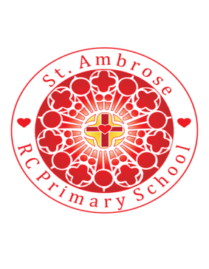
St Ambrose R.C. Primary School
Loving minds
hearts
hands.

Princess Road
Chorlton-cum-Hardy
Manchester M21 7QA
Tel: (0161) 445 3299

Head teacher: Mrs R Vayro
Email: head@st-ambrose.manchester.sch.uk
Website: www.st-ambrose.manchester.sch.uk

Year 3 Autumn Term: Share in our learning
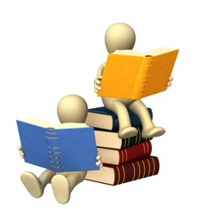
Home learning and Reading
Daily reading is extremely important. We are listening to your child read every day in school and we expect you to listen to your child read every day for 5-10 minutes at home. Please sign their reading record every time you read with them. We will have a competition to see who has read the most! For home learning, children will continue to take home a maths and grammar workbooks. This will be sent home on Thursday and one page should be completed and returned to school by Tuesday morning. I put the page to be completed on the school website and also ask the children to write it in their reading records. I choose the page linked to the topic we are learning in class to consolidate this. The children may also be given a topic research task on some weeks. Children who do not complete their home learning will have to catch up at break time. Spellings and times tables will be sent home every Thursday to practise for a test the following week. These can also be found on the Year 3 page of the website each week. Please practise daily with your child.
RE
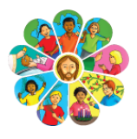
Our first RE topic is ‘Family – Homes’. In lessons, we are learning to think about what it means to be part of a family and understand God’s vision for every family. Children will consider the different types of families and homes we have. We will be learning to follow Jesus’ example of a happy and caring family and will reflect on how God is with us always. Collective worship happens every morning and each class has an additional session in the prayer garden. In Year 3, the children will begin to plan and deliver collective worship each day with support from adults.
Maths
Children will continue their mathematics learning through the Maths No Problem scheme. The first two weeks will focus on place value – numbers to 1000. Here, children will count in hundreds, tens and ones before comparing and ordering numbers and recognising, describing and completing number patterns. Around week 3, we will move to addition and subtraction including renaming and regrouping hundreds, tens and ones. Children will have the opportunity to use visual and concrete materials to help them with their learning and there will be a big focus on problem solving and reasoning to deepen their understanding. We will also catch up on some of the learning that was not completed in Year 2 due to school closure.

English
Children will continue to follow either the Read Write Inc phonics programme or Literacy and Language. In Literacy and Language, children will be studying fiction (twisted fairytales) and non-fiction texts (instruction texts) and will have the chance to write their own version of each. The twisted fairytale text we will study is called “The true story of the three little pigs.” It is based around the wolf’s perspective of what happened that day and children will write their own version of Little Red Riding Hood, imagining the wolf is a good character who has been misunderstood! Later, we will create instructions on how to wash a woolly mammoth.
Topic: Stone Age to Iron Age
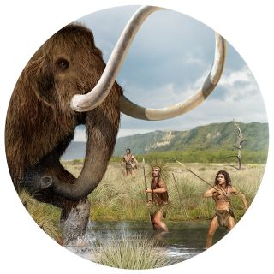
This term, our history topic will focus on the changes in Britain during the Stone Age to the Iron Age period. We will take a journey through time to discover what our earliest ancestors might have looked like, how they were able to survive, where they settled and how they lived and see the changes that happened through to the Iron age. During the Bronze Age and Iron Age people lived in roundhouses. These could be very large and would have housed many people. One household might have had two houses, one for living and one for cooking and making things. In the Iron Age, these houses were sometimes rectangular and were often gathered in farming communities on hills. However, in the Stone Age people lived in caves and followed the herds of animals.
Science

In Science, the Year 3 children are going to become ‘Rock Detectives’. The topic will begin by analysing the properties of different rocks and recognising how and where rocks are used. Children will test and compare rocks to identify which is the hardest, which are waterproof and how rocks change over time. The topic will finish with a look at soils and we will explore different types of fossils. Each science lesson will have a big focus on children working scientifically with practical enquiries, gathering data and evidence and presenting their findings. Rocks are all around us, can you spot any man made or natural rocks on your walk to and from school?
Art
In art, we will focus on the artist Rene Gruau and compare his work to that of William Kentridge. We will develop skills in drawing, shading and using different medium including different grades of pencil and other drawing implements.
Computing
The focus for the first Autumn half term will be online safety. Children will be learning about using technology safely, respectfully and responsibly. They will start to recognise acceptable and unacceptable behaviour online and identify some ways to report concerns about content. Children will use computers and Ipads.
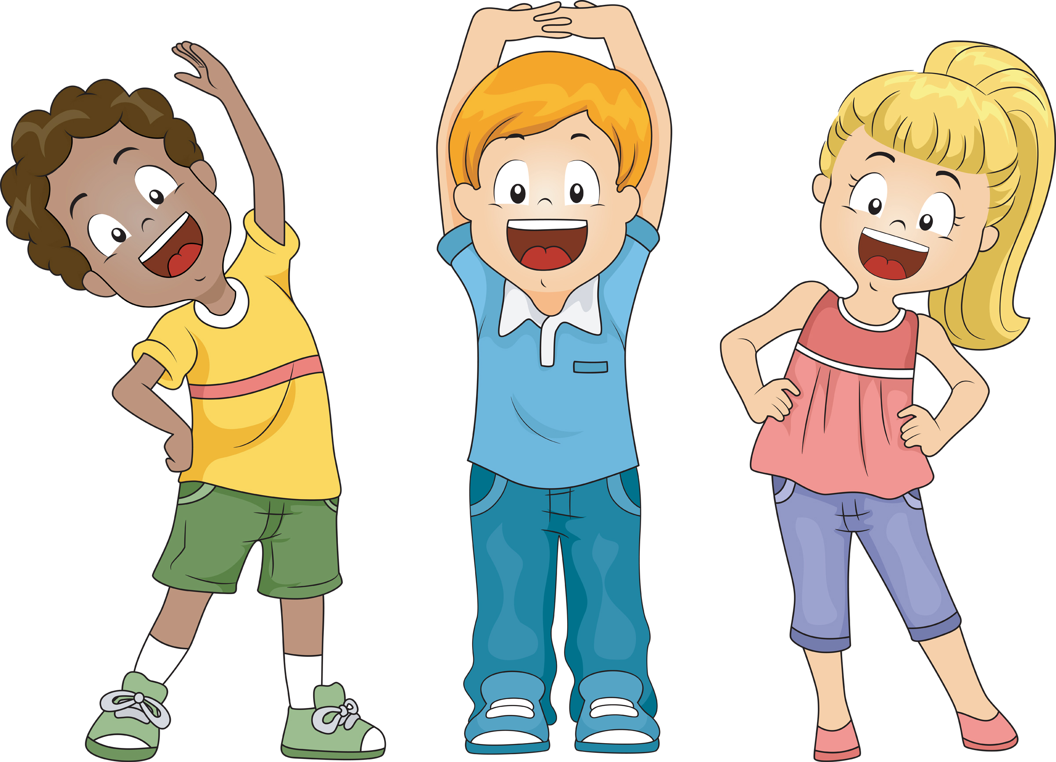
P.E.
In Year 3, children will have P.E. with Mr Warburton on Mondays and Wednesdays. Please ensure that they have the correct PE kit in school and that it stays in school for the half term: plain white t-shirt, navy or black shorts and pumps or trainers. During the first half term, we will focus on health related fitness.

Music
In Year 3, children will be starting their music learning with pulse and rhythm – a pulse is a steady beat whilst rhythm is the pattern of long and short sounds in a song. Lessons take place every Wednesday morning.

French
Children begin to learn French in Year 3. In the autumn term, children will be focusing on greetings. This will begin with simple greetings before moving on to asking and responding to questions about name and age. In lessons, children will practise reading, writing, speaking, listening and responding each lesson.

Useful websites
www.st-ambrose.manchester.sch.uk www.bbc.co.uk/bitesize/ks2
https://mybookblog.org/plogin/st-ambrose-rc-primar/ https://ttrockstars.com/
https://www.purplemash.com/sch/stambrosem21
Please look at our class homepage on our school website. This will be regularly updated with lots of information about all the exciting things we’ll be getting up to this year. If there is anything you’d like to see on there, please let me know.

