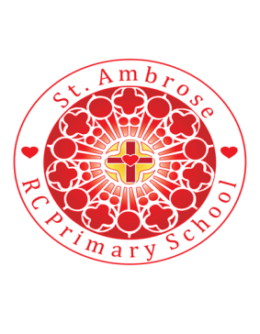
St Ambrose R.C. Primary School
Loving minds
hearts
hands.

Princess Road
Chorlton-cum-Hardy
Manchester M21 7QA
Tel: (0161) 445 3299

Head teacher: Mrs R Vayro
Email: head@st-ambrose.manchester.sch.uk
Website: www.st-ambrose.manchester.sch.uk

Autumn 1 2020-21: This term we will be learning lots of new and exciting things!
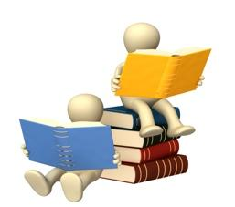
Home learning and Reading
Weekly spellings will be given out every Monday and tested on the following Friday. Daily reading is extremely important. We are listening to your child read every day in school and we expect you to listen to your child read every day for 5-10 minutes at home. Please sign their reading record every time you read with them. Reading records are checked daily. Maths and English home learning books will be given out every Thursday. The designated pages should be completed and returned to school by the following Tuesday morning. Challenges will be set on Times Table Rockstars and Purple Mash. The children have their logins inside their reading records.

Maths: Maths No Problem
This half term the children will be continuing their maths learning through MNP, and will begin the year by focusing on ‘Number and Place Value to 100’, ‘Addition and subtraction’ and ‘Multiplication of 2, 5- and 10-times tables’.
Alongside MNP, the children will also be challenging themselves and others with weekly Times Table Rockstar’s home-learning. In Year 2 the children need to be secure in the 2, 5- and 10-times tables.
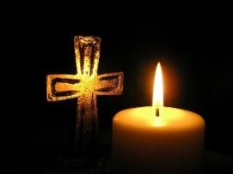
RE: Domestic Church: Beginnings, Signs and Symbols
In RE, we will be looking at ‘Beginnings’; thinking about the beginning of the world, the beginning of our own lives and new beginnings. The children will explore God’s creation and know that God created them too so that they can share their talents with the world. They will be given opportunities to wonder about the beauty around them, and will be able to describe kind, loving people that God created.
We will then be moving onto exploring the topic of Baptism, the signs and symbols connected to that rite and their importance.

English: RWI and Cracking Comprehension
We are continuing to follow the phonics reading and writing scheme; Read Write Inc, that enables your child to read more efficiently and improve their writing skills. They will continue to learn and practise how to decode and blend sounds which will help them read and write sentences confidently. Each week, there is a changeover of books so the children will be introduced to a wide range of writing genres.
Alongside RWI lessons the children will be continuing with ‘Cracking Comprehension’, which will ensure the children are able to read texts for understanding, and answer questions about what they have read using the text. It will also continue to develop the skills of scanning, sequencing and predicting in order to become a confident reader. You can support your child with their comprehension by reading a range of texts and asking why and how questions about the title, characters and events of the story.

Science: Plant Detectives
Through ‘Snap Science’ the children will be exploring ‘plants’ building on their EYFS and Year 1 knowledge and understanding. Working scientifically, they will learn to identify and name a variety of common and wild plants and explore, observe and compare the basic structure of common flowering plants and trees.

Topic: History: The Great Fire of London
In History the children will be exploring The Great Fire of London. They will be looking closely at timelines, sequencing events chronologically, and identifying and comparing the similarities and differences of the past and present. This will expand and develop their awareness of the past and their understanding of the passage of time. The children will also be looking at information from a range of primary and secondary sources and begin to further develop their historical enquiry skills by evaluating the sources. At the end of the topic the children should be able to talk about this significant event in history beyond living memory.
Art: Drawing: Portraits

In Art the children will be exploring the art of Leonardo Da Vinci and Gillian Carnegie. Focusing on drawing portraits and how to create and use tone and texture, the children will explore, design, create and evaluate their own self-portraits.
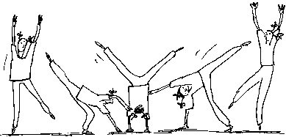
P.E: Gym
The children will begin the year by exploring movement skills in gymnastics. They will have P.E twice a week so please ensure your child brings their P.E kit in at the beginning of term so it is in school every day.
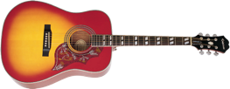
Music:
The children will be listening to and exploring a range of different musical genres and styles. They will be exploring rhythms and tempo with percussion and a variety of musical instruments
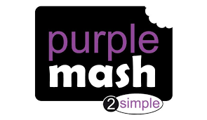
Computing: Purple Mash: Online Safety
In computing the children will be continuing with Purple Mash. They will be focusing on online safety and its importance this half term. The children all have their own individual Purple Mash logins which are glued inside their reading records.
Useful websites and further information:

www.st-ambrose.manchester.sch.uk
www.bbc.co.uk/bitesize/ks2
https://mybookblog.org/plogin/st-ambrose-rc-primar/

BBC Bitesize is an excellent resource for Maths work and English work as well as Science.
DK Find Out has some excellent information on materials. Take a look!

Please look at our class homepage on our school website. If there is anything you’d like to see on there, please let me know.

