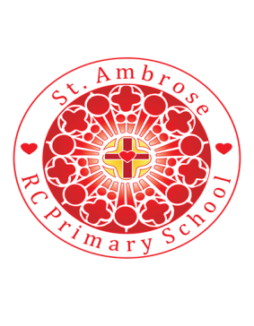
St Ambrose R.C. Primary School
Loving minds
hearts
hands.

Princess Road
Chorlton-cum-Hardy
Manchester M21 7QA
Tel: (0161) 445 3299

Head teacher: Mrs R Vayro
Email: head@st-ambrose.manchester.sch.uk
Website: www.st-ambrose.manchester.sch.uk

This term we will be learning lots of new and exciting things!
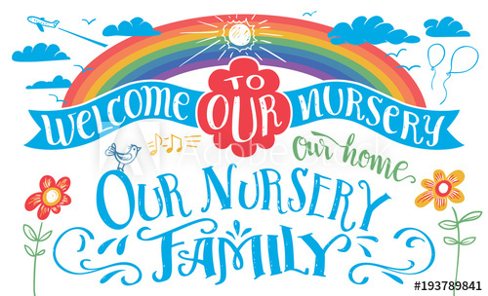
A warm welcome to you all, those of you joining our Nursery for the first time and those of you have been part of our family for a while.

This letter helps you to understand what we will be learning in the first half term. However, the most important things we will be doing are settling in, making friends and getting to know each other.
EYFS curriculum
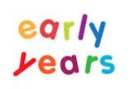
In the Early Years Foundation stage there are seven areas of learning;

Prime Areas: Personal, Social and Emotional Development, Communication and Language and Physical Development.
Specific Area: Literacy, Maths, Understanding the Wolrld, Expressive Arts and Design

The prime areas are the main focus and priority of the curriculum in Nursery. This is because these create a secure foundation for the specific areas to build on. We cpver all areas of learning, however, especially as the children are settling in development in the prime areas is key. More information about the curriculum can be found on the Virtual Meet the teacher presentation on the class page.


RE
Our topic in RE this term is 'Welcome'. We will enjoy welcoming new faces to our family and settling in to our nursery routine.
The children will learn our rules and routines to make sure that they know how to use the environment. We will think about ways in which we can welcome each other and help each other to feel happy. We will look at what makes a good friend and how this will help us to welcome others.
Topic
Each week the children are introduced to a new nursery rhyme. Learning rhymes supports the children's speaking, listening and understanding. We encourage the children to join in with the words and have actions to go with each rhyme. As we explore different nursery rhymes each week, we read related stories and provide learning opportunities inside and outside the classroom to enhance their learning. We will use lots of props and images to help with the children’s understanding. We will then use our speaking and listening skills to retell the rhymes and create our own versions with musical instruments. We will also be drawing our own characters and labelling it with teacher support.
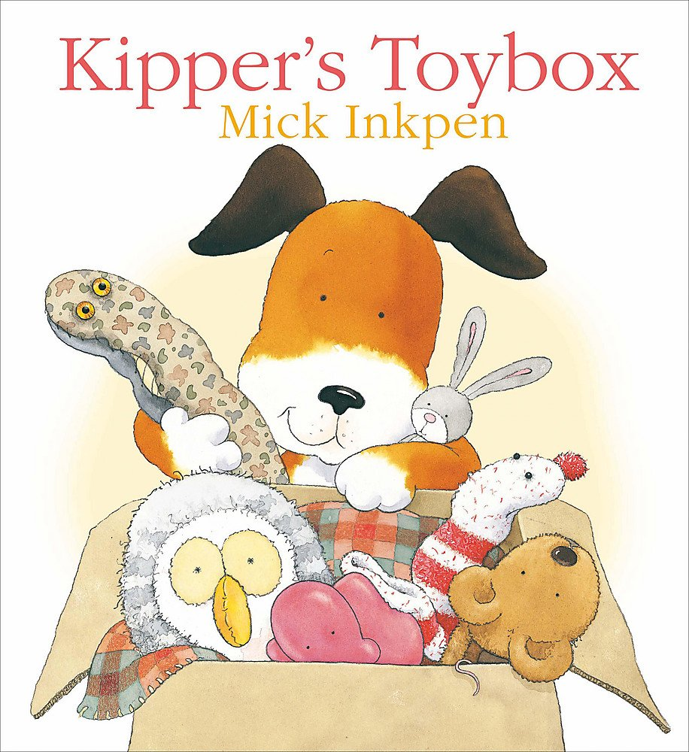
This term for numeracy we will sing number rhymes that link with the nursery rhymes, focussing on counting to five. For example, when we introduce Incy Wincy Spider, we will sing 5 Little Spiders Sitting on a Web.

After our topic on Nursery rhymes we will be looking at the story ‘Kipper’s Toybox.’ Each half term we learn through a quality text which allows us to explore a wider topic. We will be doing lots of talking about our favourite toys, developing our confidence and language. We will draw and paint our own pictures of toys and will look at toys from the past.
Some useful tips when reading with your child:
- Sit close together when sharing a book and encourage your child to hold the book themselves and turn the pages
- Point to the words as you read so your child becomes aware of where we start when reading and the direction we read in.
- When you talk to your child about what’s going on in a book, give them lots of time to think and answer (count to ten as your child thinks!). Try to ask questions that don’t require just yes or no answers. For example, ask them what they think will happen next ask or about how a character might be feeling
- Sharing books isn’t just about the words - point to the pictures and ask your child to tell the story in their own words or what they think is happening in the picture.
- Using a puppet to act out a story can help your child to understand what's going on and learn how to pretend play. Why not pick a character from your book and use the puppet to show what they are doing?
- And lastly – make it fun. It doesn’t matter how you read with a child, as long as you both enjoy the time together.
Send us a photograph of you and your child reading together!
I have updated our class page with all the information you should need and more detail about the curriculum. This will be updated regularly so please keep checking.
www.st-ambrose.manchester.sch.uk/nursery

