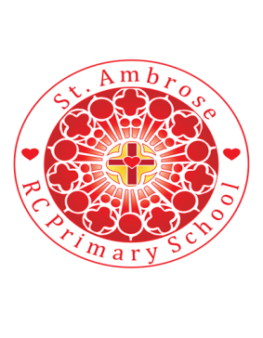
St Ambrose R.C. Primary School
Loving minds
hearts
hands.

Princess Road
Chorlton-cum-Hardy
Manchester M21 7QA
Tel: (0161) 445 3299

Head teacher: Mrs R Vayro
Email: head@st-ambrose.manchester.sch.uk
Website: www.st-ambrose.manchester.sch.uk

Autumn 1 2020-21: Welcome to your final year at St. Ambrose!
Home learning and Reading

Daily reading is extremely important. We are listening to your child read every day in school and we expect you to listen to your child read every day for 5-10 minutes at home. Please sign their reading record every time you read with them. To extend your child’s learning, please ask them questions from the KS2 reading content domains sheet. My Bookblog is being used and children are encouraged to use this resource to develop their reading comprehension skills. If your child reads on My Bookblog rather than their class book, please note this in their reading record. For home learning, children will have a mental maths book and a grammar, punctuation and spelling book. These will be sent home on Thursday and the designated pages should be completed and returned to school by Tuesday morning. Spellings will be sent home every Thursday to practise for a spelling test on the following Tuesday. Please practise daily with your child. Your child will also have a weekly times tables test. It is really important that this learning is supported and consolidated at home.
Maths:

Number and Place Value: The children will read, write, order and compare numbers to 10,000,000 and determine the value of each digit, determine the value of digits to tens of millions, round numbers to the nearest ten, hundred, thousand etc. They will use negative numbers in context and calculate intervals across zero.
Addition, subtraction, multiplication and division: The children will solve addition and subtraction multi step problems in contexts, deciding which operations and methods to use and why. They will multiply multi-digit number up to 4 digits by a 2 digit number using the formal written method of long multiplication, divide numbers up to 4 digits by a 2 digit whole number using the formal written method of long division, and interpret remainders as whole number remainders, fractions or by rounding as appropriate for the context. The children will identify common factors, common multiples and prime numbers and perform mental calculations, including with mixed operations and large numbers.
It is crucial that your child knows their times and division tables and can recall them quickly.
Please use TT Rockstars to support this learning.

RE: Domestic Church: Loving
Through this unit the children will learn about pupils will know and understand ‘the love and care of people’. They will know and understand God’s love is unconditional and never ending. The children will develop their understanding that we are all loved and that we can grow in love. An understanding that forgiveness is a crucial part of unconditional love will be developed.
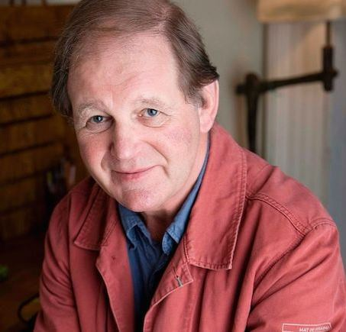
English: Beowulf by Michael Morpurgo
In this unit the children will explore Morpurgo’s themes and style of writing as well as analysing how he creates atmosphere, character and imagery. The children will write in role as the central character and compose a multi-layered text which supports their narrative writing. In the non-fiction text the children will explore explanation texts.

Science: Body Pump
In this module the children will build on their learning about the human body from Key Stage 1, when they learned that humans and other animals need water, food and air in order to survive, and also during lower Key Stage 2, when they investigated the muscular, skeletal and digestive systems. In this module, children learn about the human circulatory system and how it enables their bodies to function. They find out about the main parts of the circulatory system: the heart, blood vessels (arteries, veins and capillaries) and blood, and how these work together to deliver oxygen and nutrients to every part of the body. They will find out how the heart works, the main components of blood and the function of the different types of blood vessels. They will also learn about how water is transported through the body and develop their understanding of the importance of water to human health.
When working scientifically during this module, children will use secondary sources of information with increasing independence in order to find answers to questions about the functions of different parts of the circulatory system that they cannot investigate first hand.
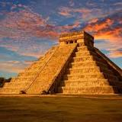
Topic: Brainwave and The Mayans
In the Brainwave Unit the children will learn about some of the recent evidence and research into the brain and learning and learn about some of the different areas of the brain and their function. They will understand the different ways that they can learn and how they can improve their learning and their attitudes to learning.
In the Mayans topic, the children will discover facts about the Ancient Maya Civilisation, considering the similarities and difference between ancient religions and different religions today. They will look at the Maya number system, locate ancient Maya Cities and find out what the Maya people grew and ate.
P.E.

In games, the children will be learning invasion games of football and basketball. In gymnastics, they will be learning Matching and Mirroring, Synchronisation and Canon. In dance, the children will create pieces related to ‘The World of Sport’ and ‘Mix and Match’. Please ensure that your child has their PE kit in school where it will stay until the end of each half term.
Music:
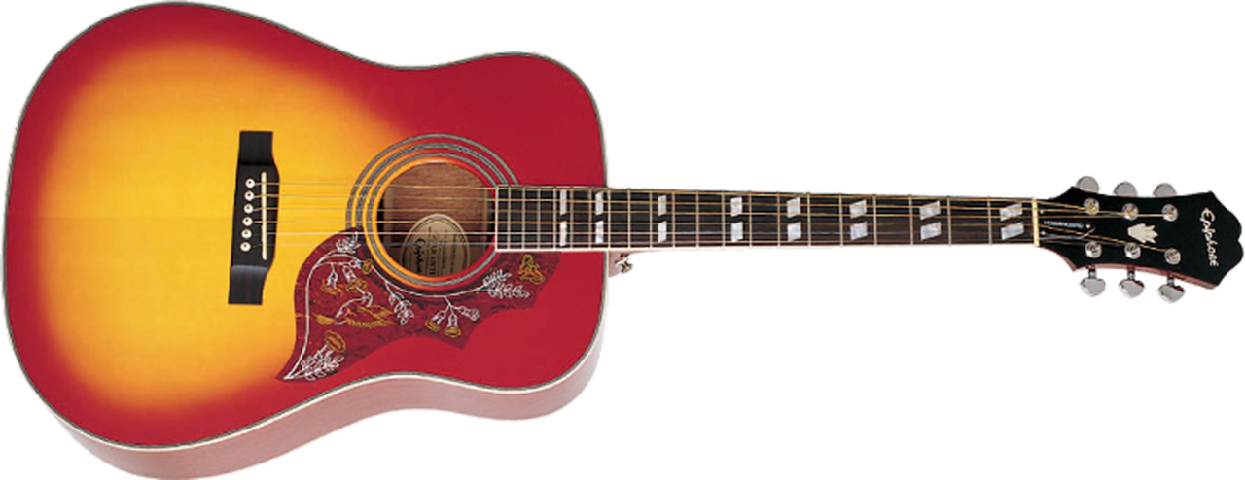
Music lessons will take place every Wednesday afternoon with Mr Leonard. In lessons, they will be listening to and composing a range of music. They will explore how music can create different moods and effects.

French:
In French, taught by Miss Smith, the children will be learning words, phrases and hold simple conversations around the topic of ‘Our School’
Useful websites and further information:
www.st-ambrose.manchester.sch.uk www.bbc.co.uk/bitesize/ks2 www.purplemash.com

https://mybookblog.org/plogin/st-ambrose-rc-primar/ https://ttrockstars.com www.satspapers.org

Please look at our class homepage on our school website. If there is anything you’d like to see on there, please let me know. If you wish to speak to me about anything, you can find me at the end of the day or arrange a meeting with the office.

