Where to go for more information  `  SEN Support Information for Parents & Carers  Contact the school  If you have any questions about the support your child is receiving, or about SEN more generally, please speak to your child’s class teacher or our SENCO.  The school’s SEN policy and information report set out more detailed information about the support available for children with SEN and disabilities.  You can access this information on our website at: https://www.st-ambrose.manchester.sch.uk/.  External links  The government’s SEND Code of Practice and a related guide for parents have more information about the topics outlined in this leaflet:  - SEND Code of Practice: 0 to 25 years, GOV.UK – DfE https://www.gov.uk/government/uploads/system/uploads/attachment_data/file/398815/SEND_Code_of_Practice_January_2015.pdf  - SEND: a guide for parents and carers, GOV.UK – DfE https://www.gov.uk/government/uploads/system/uploads/attachment_data/file/417435/Special_educational_needs_and_disabilites_guide_for_parents_and_carers.pdf  SEND Local Offer  The Manchester Local Offer helps children, young people and their parents to understand what services and support they can expect from a range of local agencies - including their statutory entitlements  https://hsm.manchester.gov.uk/kb5/manchester/directory/localoffer.page?localofferchannel=0 |  | Glossary of terms  EHC plan - Education, Health and Care Plan  SEN - Special Educational Needs  SENCO - SEN Co-ordinator  SEND - SEN and Disability |  | 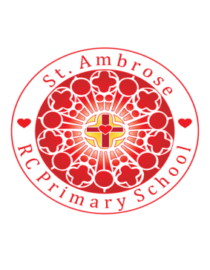  Loving minds  hearts  hands.
What is SEN?  Some children find learning more challenging than others and may need extra support to achieve their full potential.  For example, they might have difficulty with:  - Expressing themselves  - Interacting with others  - Reading, writing and maths  - Following lessons  - Controlling their emotions  - Sensory or physical mobility  These difficulties can be barriers to learning. Schools assess all children to identify their strengths and needs and how they can best be supported.  Children who need extra help with their learning may receive additional support under one of the following categories:  - SEN support  - An EHC plan  WAVE 1  High quality, differentiated teaching  For all children | We may refer to the ‘wave’ system to determine the type of support best suited to each child: | What is SEN support?  SEN support describes the additional help that assists children to access the curriculum.  This might include:  - Extra help in the classroom  - Small group or one-to-one learning  - Support from specialists such as speech and language therapists  Schools will work with parents when agreeing what support to provide and what it will achieve.  What are EHC plans?  If your child has more complex needs, he or she might already have a statement of SEN or be assessed for an EHC plan.  WAVE 2  High quality teaching plus extra short-term support  For children making slower progress  WAVE 3  SEN support: additional long-term, individualised support  For children still making less progress than their classmates |  | FAQs  How will the school decide what type of support my child receives?  Every child’s needs are different, and may change over time.  The school will assess each child’s needs closely to identify which support suits him/her best.  The school will also regularly review the support your child receives to see what is working and what isn’t, and incorporate your views on this too.  How do I know if my child needs SEN support?  If your child is not making expected progress for his/her year group, he/she may need SEN support.  The school will discuss your child’s needs with you before placing your child on SEN support.  What if I think my child needs further support?  Please speak to your child’s class teacher or the SENCO, Jane Hoban.  WAVE 4  EHC plan  For children with more complex needs

