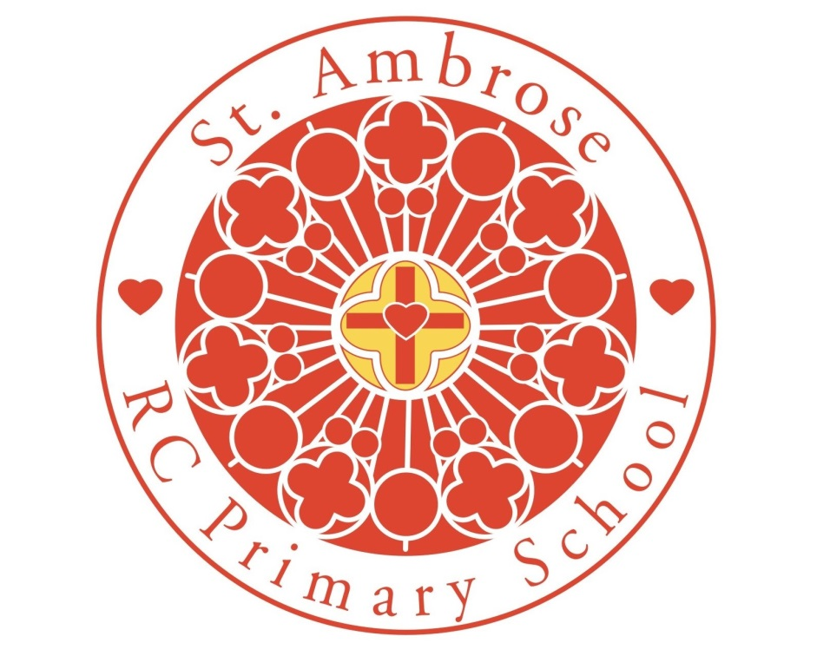

**Art Policy 2024-2025**

|  |  |  |
| --- | --- | --- |
| **Approved by:** |  | **Date:** 04.09.24 |
| **Last reviewed on:** | September 2024 | |
| **Next review due by:** | September 2025 | |

In the light of the Mission Statement, Inclusion and Assessment Policies, this is the policy statement for the delivery of Art at St Ambrose RC Primary School.

**Rationale**   
At St Ambrose R.C Primary we provide a positive, caring environment, that ensures every child has the opportunity to reach their full potential. We embrace Catholic values and ensure all children are ready for their next steps. We are committed to providing all children with learning opportunities to engage in Art and Design, we believe that every child within our school should have full access to Art and Design as laid down in the National Curriculum regardless of age, gender or ability. We seek to ensure that our teaching reﬂects the current guidance to schools, which emphasises the particular importance of designing and making.

**Purpose**

The purpose of Art and Design education is to give pupils the skills, concepts and knowledge necessary for them to express their responses to ideas and experiences in a visual or tactile form. It fires their imagination and is a fundamental means of personal expression.

While it is essentially a practical subject, art should provide opportunities for reflection and, with increasing sensitivity, pupils should acquire the ability to make informed, critical responses to their own work and that of others.

There is great pleasure to be derived from Art and Design and, through deeper understanding; pupils can gain access to cultural richness and diversity. The appreciation and enjoyment of the visual arts enriches all our lives.

At St Ambrose we believe that the learning of Art provides a valuable educational as well as social and cultural experiences for children of all ages. Pupils develop life skills and have the chance to extend their knowledge of practitioners works.

**Our aims for Art are:**

The aims of Art and Design are:  
• To enable all children to have access to a varied range of high quality art experiences  
• To provide an imaginative, innovative and co-ordinated art programme which will foster enthusiasm for art and design amongst all the children  
• To foster an enjoyment and appreciation of the visual arts and a knowledge of artists, craftspeople and designers, through links with the local and wider multicultural community.  
• To stimulate children’s creativity and imagination by providing visual, tactile and sensory experience  
• To help children explore the world at first hand, using all their senses and experimentation, and so gain knowledge and understanding of the world in which they live  
• To develop children’s understanding of colour, form, texture, pattern and their ability to use materials and processes to communicate ideas, feelings and meanings  
• To inspire confidence, value and pleasure in art  
• To cultivate children’s aesthetic awareness and enable them to make informed judgements about art and become actively involved in shaping environments  
• To teach children to express their own ideas, feelings, thoughts and experiences  
• To develop children’s design capability  
• To enhance children’s ability to value the contribution made by artists, craft workers and designers and respond critically and imaginatively to ideas, images and objects.

**Methods:**   
  
St Ambrose follows the revised National Curriculum for Art and Design Technology at Key stage 1 and 2. All pupils have one lesson in Art or Design Technology every week and these subjects will be embedded in the curriculum as far is possible. Foundation Stage pupils will be taught and encouraged to use simple Art and Design Technology skills. The children will have a focus on one area each half term, covering topics of each subject throughout the academic year.

**Curriculum**

The children undertake a balanced programme that takes account of abilities, aptitudes and physical, emotional and intellectual development. Through Art and Design, the children learn a range of skills, concepts, attitudes, techniques and methods of working.

**Early Years**  
During the Early Years, young children will be given the opportunity to explore colour, texture, shape and form in two and three dimensions. The children will have access to a wide range of constructions, collage, painting and drawing activities, using appropriate tools and art materials. In order to tap their artistic potential, the children will be encouraged to develop their own creative ideas.

**Key Stage 1**During Key Stage 1, Art and Design is about expanding children’s creativity and imagination through providing art, craft and design activities relating to the children’s own identity and experiences, to natural and manufactured objects and materials with which they are familiar, and the locality in which they live.  
• Children will explore the visual, tactile and sensory qualities of materials and processes and begin to understand and use colour, shape and space, pattern and texture, to represent their own ideas and feelings.  
• Children will focus on the work of artists, craftspeople, other cultures, and sculptors and designers by asking and answering questions, such as: ‘What is it like?’ ‘What do I think about it?’

**Key Stage 2**  
During Key Stage 2, Art and Design is about fostering children’s creativity and imagination by building on their knowledge, skills and understanding of materials and processes, through providing more complex activities. Children’s experiences help them to understand the diverse roles and functions of Art and Design in the world around them.

**Progression**

There should be progress from year to year in both application of skills and understanding of the subject. The National Curriculum level descriptors indicate progression in the following key areas

## Pupils in Key Stage 1 should be taught:

Ar1/1.1    to use a range of materials creatively to design and make products

Ar1/1.2    to use drawing, painting and sculpture to develop and share their ideas, experiences and imagination

Ar1/1.3    to develop a wide range of art and design techniques in using colour, pattern, texture, line, shape, form and space

Ar1/1.4    about the work of a range of artists, craft makers and designers, describing the differences and similarities between different practices and disciplines, and making links to their own work.

Pupils in Key Stage 2 should be taught:

Ar2/1.1    to create sketch books to record their observations and use them to review and revisit ideas

Ar2/1.2    to improve their mastery of art and design techniques, including drawing, painting and sculpture with a range of materials

Ar2/1.3    about great artists, architects and designers in history.

**Progression and Continuity**

The school uses a variety of teaching and learning styles in art and design lessons. Our principal aim is to develop the children’s knowledge, skills and understanding in art and design. We ensure that the act of investigating and making includes exploring and developing ideas, evaluating and developing work. We do this through a mixture of direct teaching and individual/ group activities. Teachers draw attention to good examples of individual performance as models for the other children. They encourage children to evaluate their own ideas and methods, and the work of others, to say what they think and feel about them. We give children the opportunity within lessons to work on their own and collaborate with others, on projects in two and three dimensions and on different scales. Children also have the opportunity to use a wide range of materials and resources including other artists’ work, educational visits and computing.

We recognise the fact that we have children of differing ability in all our classes, and so we provide suitable learning opportunities for all children by matching the challenge of the task to the ability of the child. We achieve this through a range of strategies which are differentiated by task, expected outcome and/or support from peers or adults.

**Art and design curriculum planning**

At St Ambrose art is taught through half termly topics, our curriculum is carefully planned to engage and excite all our learners. These plans define what we will teach and ensure an appropriate balance and distribution of work across each Key Stage.

**Monitoring**

Each child has an art sketchbook which serves as a cumulative record of their work and is passed on to the next teacher at the end of each year. Samples of children’s work are also collected. Monitoring takes place regularly through sampling children’s work, teacher planning and lesson observations.

**ICT**

In addition Art and Design provides the opportunity to develop the skills of ICT such as:  
• Creating designs using drawing packages

• Recording using photographs using cameras and I Pads

• Designing, annotating and projecting plans using Purple Mash

• Access the internet to research information

Each classroom is ﬁtted with an interactive whiteboard enabling the teacher to use video clips and demonstration programmes to enrich lessons.

**Assessment and Monitoring**

This is then analysed against National Curriculum bands. Evidence for making these judgments will be gathered through discussion and observation of the pupil during the lesson and by the child's recording of the activities, e.g. planning, designing, and photographing practical activities. All levels are based upon teacher assessment Children are also given the opportunity to fully participate in the assessment process, through peer, self and group assessments. The learning line is used to reﬂect on learning. Children are monitored on a regular basis to check progress. Assessment and Recording is an integral part of the teaching process. Assessment is used to inform planning and to facilitate differentiation. The assessment of children’s work is on-going to ensure that understanding is being achieved and that progress is being made.

**Inclusion**

All our children have access to the Art and Design curriculum, regardless of their ability, gender, physical disability or their social, cultural or ethnic background. Where possible, provision is made to support individuals or groups of SEND children or those with a disability so that they can participate effectively in Design and Technology lessons. Likewise, provision is made for our More Able children and our New Arrivals so that their needs are also met. All children are encouraged to achieve as high standard as possible.

**Rights of the Child**  
The Art and Design curriculum takes in to account Article 13, 15, 29 and 31 of the UN Convention on the rights of the child.

**Resources**  
There are a wide range of resources to support the teaching of art and design across the school. All classes have a range of basic resources kept in the classroom; large bottles of paint and some other equipment, including specialist books are kept centrally. The Art and Design and Technology coordinator is responsible for the management of the resources; all staff are responsible for the organisation and maintaining of the resources. An audit is carried out to ensure resources are readily available.

Visits are planned to enhance learning and give hands on activity. People with an interest, or expertise, in a particular topic or area of art could be invited into school to work with the children. These might be parents, grandparents, other family members, neighbours or representatives of the local community

**Monitoring and Evaluation of Subject**

To monitor and evaluate Art the co-ordinator:

• Carries out pupil/staff and parent questionnaires  
• Monitor teachers’ planning  
• Displays examples of good work from each year group around school  
• Monitors the standard of children’s work via work scrutiny  
• Provides and evaluates termly actions  
• Analyse termly data and provide feedback to teachers  
• Share and highlight areas of development  
• Share examples of lesson plans